

FINAL REPORT

MIS



Faryal AMir

01-1333102-121

Bse-7A

Table of Contents

1. INTRODUCTION 2

1.1 Architecture: 2

1.2 Tool used: 2

2. DESIGN AND ANALYSIS 3

2.1 ER Diagram: 3

2.2 Data Flow Diagram: 4

2.3 Relation Schema 6

2.4Use Case diagram: 7

3. IMPLEMENTATION: 8



# INTRODUCTION

‘**Fantasy ‘**an interesting website in which people upload pictures and videos. At the end of the month on the basis of votes best one wins the price

There are two sections of the website

1. Pictures
2. Videos

Every posted thing on a website cost **1$** and at the end of the month winner gets **10$** *price*.

At the end of the month on the basis of likes 2 winners will be chosen. One will be from picture section and other will be from video section

## 1.1 Architecture:

Fantasy is the web based internet business. Front end includes HTML and PHP back end includes ‘PHP’ and for processing java script is use. Earning forecast for my website is that when someone post anything on the website, that person cost 1$. That means my earning depend upon the posts of the people.

## Tool used:

1. Umlet ( for designing diagrams )
2. Sql yog ( for creation of tables )
3. WAMP server ( for running the website )

# DESIGN AND ANALYSIS

# 

## 2.1 ER Diagram:

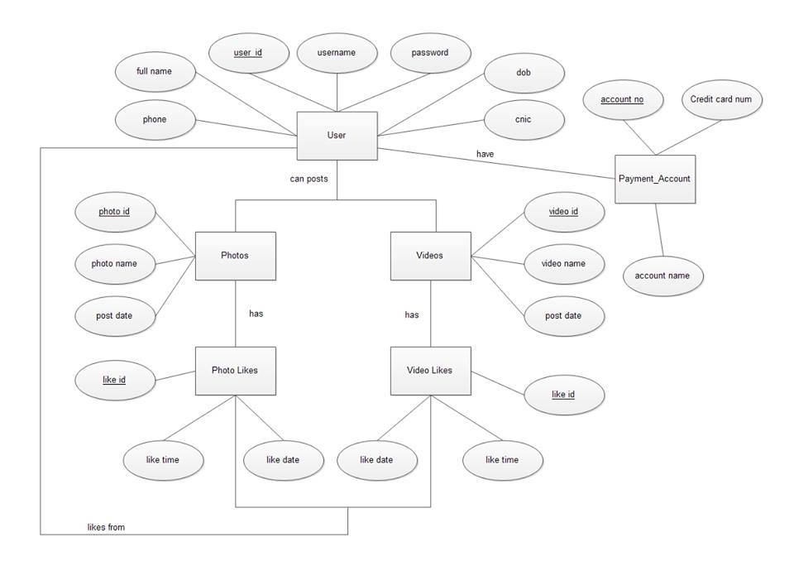

## Data Flow Diagram:

O-LEVEL

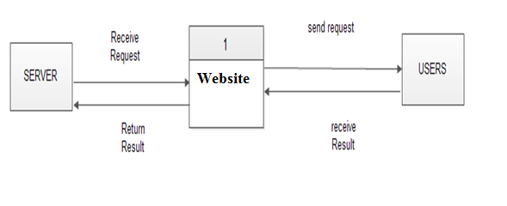

1-LEVEL

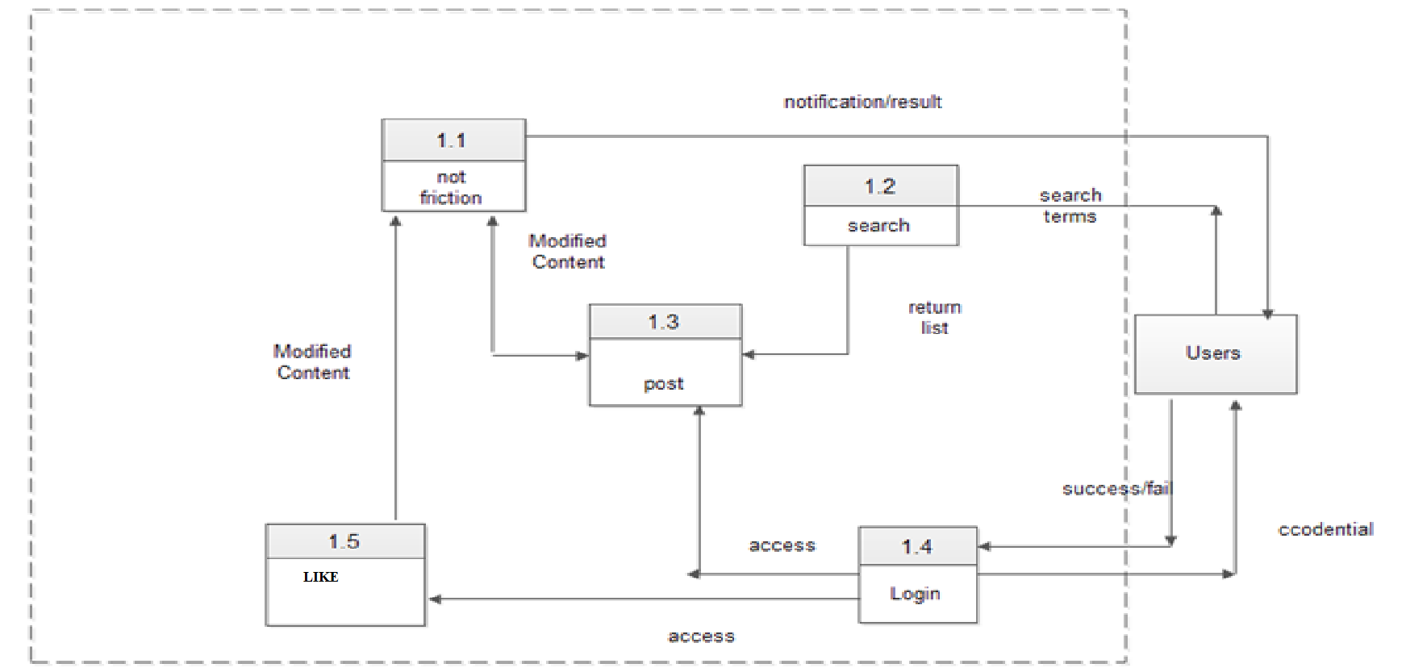

2-LEVEL

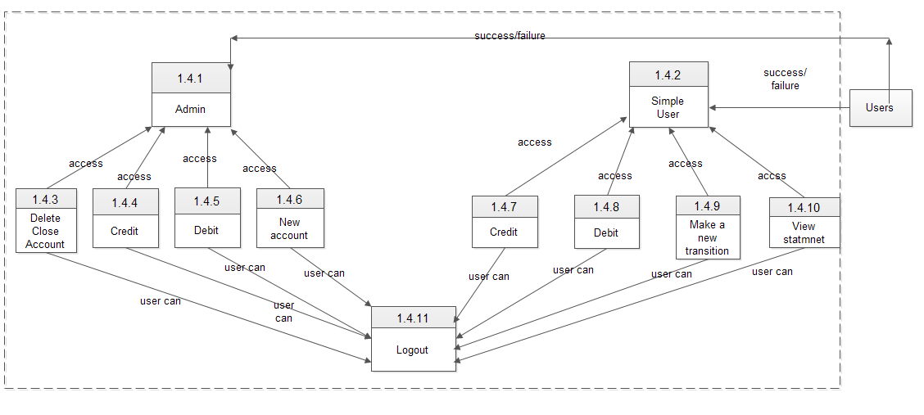

## Relation Schema

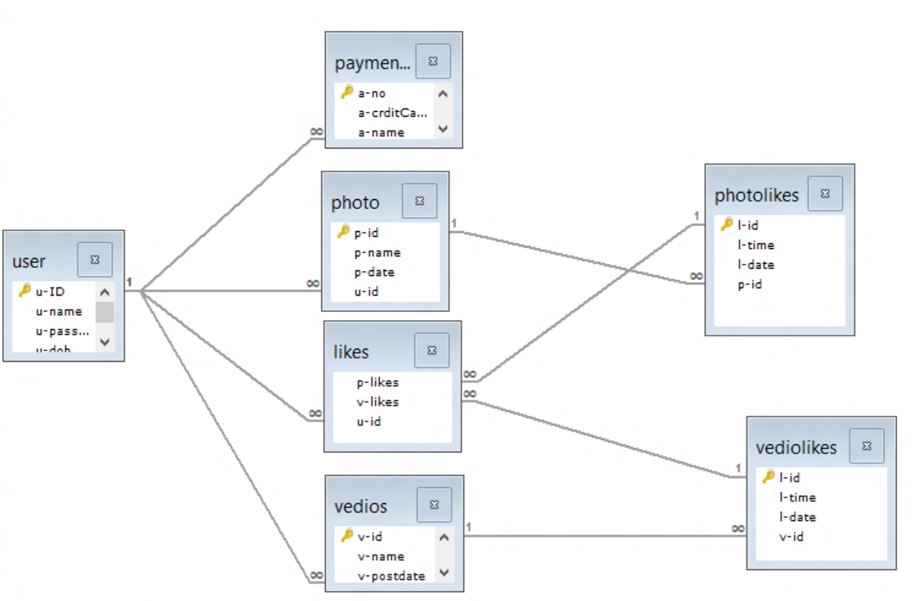

## 2.4Use Case diagram:

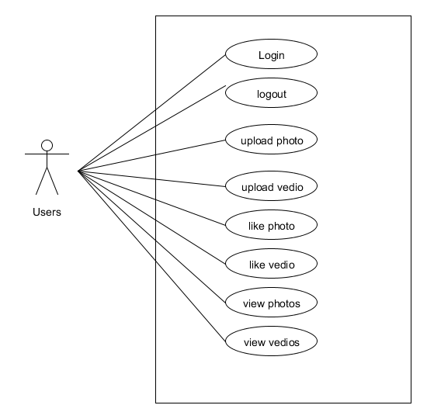

# IMPLEMENTATION:

Here are some screen shots of implemented work

